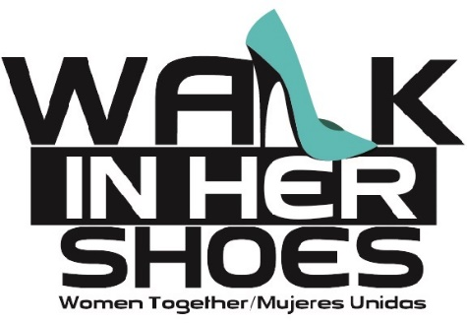

**15th Annual *“Walk in Her Shoes”***

**5K Run/Walk**

**April 26, 2025 / 8:00 am**

**Edinburg Municipal Park**

**Sponsorship Opportunities:**

*All proceeds to benefit Mujeres Unidas*

**____ Title Sponsor $5,000**

* Logo/Name on Official “Walk in Her Shoes” T-Shirt listed as Title Sponsor
* Logo/Name listed as Title Sponsor on posters, website, social media, and all event promotions
* Logo/Name signage at the Finish Line and (2 signs) along the race route
* Company name to be recognized in newspaper releases and tv/radio announcements
* Opportunity to distribute promotional materials at event
* 2 Teams of 10 (additional participants $25 each)

**____ Water Station Sponsor 3,000**

* Logo/Name at Water Station
* Logo/Name on t-shirts, posters, website, social media, and all event promotions
* Company name to be recognized in newspaper releases and tv/radio announcements
* Opportunity to distribute promotional materials at event
* 16 complimentary entry fees (additional participants $25 each)

**____ Mile Marker Sponsor $2,000**

* Logo/Name at Mile Marker
* Logo/Name on t-shirts, posters, website, social media, and all event promotions
* Company name to be recognized in newspaper releases and tv/radio announcements
* Opportunity to distribute promotional materials at event
* 12 complimentary entry fees (additional participants $25 each)

**____ Starting Line Sponsor $1,000**

* Logo/Name at Starting Line
* Logo/Name on event t-shirts, website, social media, and agency newsletter
* Opportunity to distribute promotional materials at event
* 8 complimentary entry fees (additional participants $25 each)

**_____Violence Has Got to Go Sponsor $500**



* Logo/Name on event t-shirts
* Opportunity to distribute promotional materials at event
* 4 complimentary entry fees (additional participants $25 each)

**_____Friend Sponsor $250**

* Opportunity to distribute promotional materials at event
* 2 complimentary entry fees (additional participants $25 each)

**Deadline to be listed as a sponsor on the event t-shirt and to submit t-shirt sizes is April 15, 2025.**

_____ I am not interested in receiving the t-shirts, please utilize my donation towards agency services.

Payment may be remitted to Women Together Foundation, 511 N. Cynthia, McAllen Texas.

For more information, please contact Event Coordinator at (956) 630-4878 / WTVolunteer_Events@yahoo.com

Business Name: _____________________________________ Contact Person: __________________________

Address: ___________________________________________ City, State, Zip: ___________________________

E-Mail: _____________________________________________ Phone #: ________________________________

Enclosed is a check for $__________ I wish to remain anonymous _____ yes ____no